Board of Trustees Report

Submitted by the
THE SPELMAN STUDENT GOVERNMENT ASSOCIATION 2013-2014

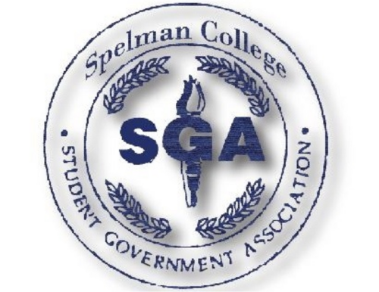

Spelman College Board of Trustees
350 Spelman Lane, S.W.
Atlanta, Georgia 30314-4399

April 24, 2014

Dear Spelman College Board of Trustee members:

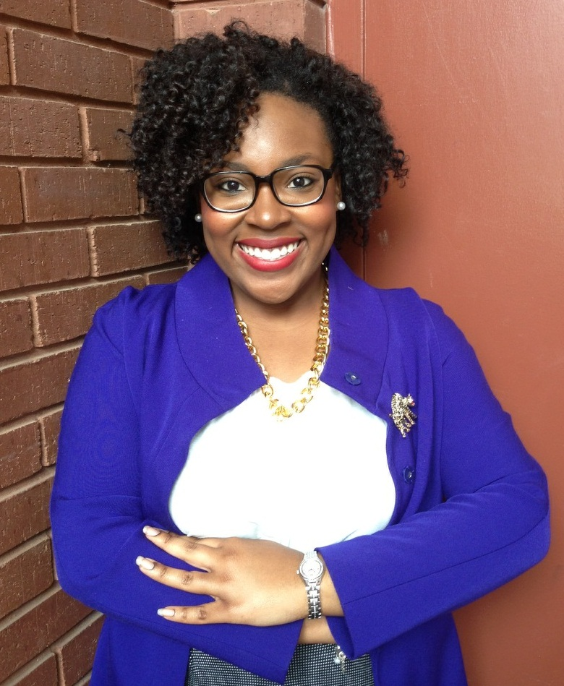
On behalf of the Spelman Student Government Association, I would like to thank you for your support. Serving as SGA President has been one of the most rewarding laps in my “Spelman Mile”. The questions, comments and concerns from Spelman College students were the source of motivation not only for me, but for this year’s administration. Student Government embarked on an ambitious agenda, the full contents and mission of which cannot be contained within this document alone. In the following pages, we provide you with a snapshot of all of the initiatives that Student Government has been a part of this year.
By combining innovative thinking with personal interactions we worked to combat student apathy with initiatives that educated and inspired our Spelman sisters. Our aim this year was to ensure that in addition to being empowered to voice their opinions, students felt confident in their ability to influence change and comfort in knowing they are supported by the Spelman Community. We have taken great pride in supporting the College’s administration in advancing Spelman forward during this remarkable period of growth and success. We are proud of the impact that the 2013-2014 Student Government Administration has had on the student body. Again, thank you for your unwavering support and dedication.

Sincerely yours for our Spelman,

Shanteal L. Lake, C’2014
SSGA President

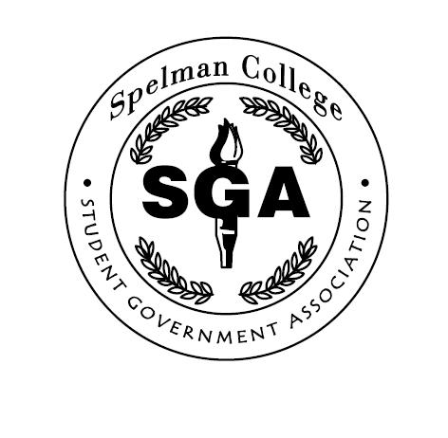
Spelman Student Government Association
Spring Board Report
April 2014

Overview

The Spelman Student Government Association has undergone tremendous transformation over the last year while continuing to grow into a productive and efficient body in the service of our sisters. Our efforts have focused primarily on community building, campus involvement, continuity, and civility through sisterhood. With regard to the former, recognizing that Spelman College attracts immensely talented students, SSGA has dedicated itself to helping create an environment that allows for the full development of its students. In this way, students are able to contribute to the ever changing Spelman Community while tapping into their unknown potential.

The ideas and opinions brought forth are intended to formulate conversations and improvements that may become a facet of the institution and can be enjoyed for years to come. As for civility, it is an undertaking as much internal as it is external. The Spelman Student Government Association actively works at operating in a civil manner while encouraging others to do so as well. We believe that in this way the college is able to function more productively, thus enhancing the Spelman experience of everyone involved.

Most importantly, SSGA is committed to creating a sense of continuity so that the lessons and gains of one year can contribute to the growth and improvement of Spelman College well into the future. Continuity, ensuring that the contributions of each student are continued, is an important element of this, as is working to foster productive relations with all aspects of the institution– the student body, registered student organizations, faculty, staff, administration, and alumnae.

This year the Spelman Student Government Association embarked on an ambitious agenda to reform its operational procedures and promote greater openness and transparency.
Though comprehensive and far reaching, the goals for this year were aimed at continuing to make Spelman College the greatest institution it can be while improving the student experience to ensure that the community grows with its students while attracting the most talented “Women that Change the World”.

- Cultivating opportunities for undergraduate research, career growth and networking
Spelman Alumnae Affairs & SSGA Civic Engagement on Capitol Hill in Washington, DC-Career Development

The Spelman Student Government Association partnered with The Office of Alumnae Affairs to host the 4th Annual Advocacy Day on Capitol Hill in Washington, D.C., on March 25-30, 2014. The trip was designed to inspire students to seek public service careers by connecting students with alumnae mentors and congressional leaders on Capitol Hill. Students were able to take part in civic engagement projects and engage in policy research. While at our nation’s capitol, students also shadowed and engaged in dialogue with United States delegates, representatives and senators. Students were even given the opportunity to attend committee meetings and budget hearings at the U.S. Capitol. As a result, some students were offered interview opportunities for internships. Students also toured the Smithsonian Museum of African Art and had dinner with
Dr. Johnnetta B. Cole, Executive Director of the Smithsonian African Art Museum and former Spelman President. The experience was enhanced this year with a Civic Engagement Project. Students participated in civic engagement/advocacy training prior to the trip, and were given an introductory foundation to support student access to, understanding, and use of public policy as an avenue for the promotion of issues and programs at the federal level. Once students were at Capitol Hill, they were divided into several groups with advocate to a select group of representatives for one of the following issues:
- War on Poverty
- Rights of Sexual Assault Survivors in the Military
- Health Care Education
- Higher Education Funding.

- Enhancing Alumnae-Student Relationships
Spelman Alumnae Affairs & SSGA Civic Engagement on Capitol Hill in Washington, DC

As mentioned earlier in the report, The Spelman Student Government Association partnered with The Office of Alumnae Affairs to host the 4th Annual Civic Engagement Day on Capitol Hill in Washington, D.C., on March 25-30, 2014.

During the trip, we hosted two Alumnae-Student cultivation activities. The first engagement was an alumnae panel discussion moderated by Nicole Venable, C’91, and was entitled “How I Made it to the Hill.” Six alumnae spoke on the panel and gave very detailed advice to the students about how they navigated Capitol Hill. The students were also able to shadow the alumnae in their current roles and positions on Capitol Hill.

The second cultivation event was an Alumnae-Student Luncheon at the Hamilton Crowne Plaza Hotel in Washington, DC. The event gave students an opportunity to hear alumnae testimonials and from Dr. Beverly Daniel Tatum, her vision for the College, the priorities of the campaign, and strategic plan (GOALS).
“Spelman on the Hill”
The 4th Annual Civic Engagement Day on Capitol Hill in Washington, D.C

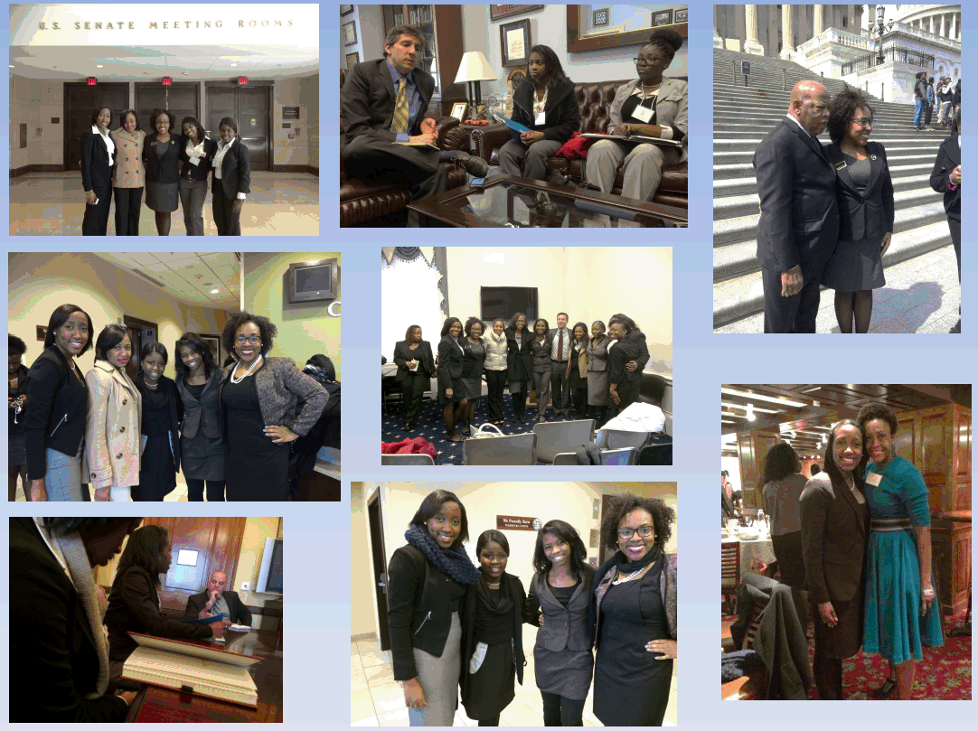

Pictured: (Congressional Visits, Tour of the Capitol Building, SSGA with Congressman John Lewis, Alumnae-Student Networking Dinner

- Capacity Building and Legitimacy Expansion
This year SSGA seeks to strengthen the relationship between our organization and Registered Student Organizations alike. We believe by ways of supporting and collaborating with organizations, it improves the sisterly climate on campus and provides structure whereby alleviating over-programming.

SAFAC

The SAFAC program is an organized system that allows Spelman College Registered Student Organizations to apply and receive financial support. Under the leadership of Amber Reid, 2013-2014 Secretary of Business and Finance, SSGA continues to grant students monthly access to their SAFAC funds.

House of Representatives
To maintain the operation of the House of Representatives (HOR) and create more effective communication between the student body and SSGA the attendance policy for HOR meetings was amended to effect organizational funding as well as eligibility for chartering on campus. Representatives were allowed to miss one meeting for the entire school year with an approved excuse. Failure to appear or provide appropriate documentation could result in a lack of SAFAC Funding or official charter. This year student attendance at HOR meetings and related events more than tripled that of last year.

RSOs of the Week
In an effort to increase RSO representation and participation in the House of Representatives, SSGA created an application for students to nominate their organization for campus recognition through SGA announcements. SSGA Vice- President, Danielle Moody had a goal to increase involvement by recognizing student leadership. This year two organizations were recognized.

1. PePers (Peer Educator Program)- These students, selected annually by their peers to provide leadership in the area of mental and emotional wellness, are trained to address issues of eating disorder prevention, self-esteem and person rights, healthy relationships, intimate violence prevention, diversity, and racism.

2. Teen Angels Society- This organization exists to groom young girls into ladies of high confidence, class, and character. Spelman students provide girls ages 7-17 with training in proper etiquette and social behavior needed in today's society.

Thanksgiving Baskets
Through Spelman Student Government Association along with several Registered Student Organizations (RSOs) partnered to collect non-perishable food items to give to those in need during the holidays. This year at total of 53 baskets and 50 turkeys were donated. A portion of the proceeds were given to Aramark employees and the remainder to the “Hosea Feed the Hungry and Homeless” organization.

- Student Requests and Concerns
Dining Concerns & Cafeteria Reform

Spelman College has made significant strides in the dining facilities located throughout the Manley Center. This year Secretary of Student Affairs, Jasmine Payne partnered with Aramark by forming a student ran committee to gather suggestions about improvements regarding Spelman Dining. The following areas were addressed:

- Fresh Fruit Market
On February 21, 2014 during Market Friday, a station was set up between Grille Works and Jamba Juice in Lower Manley. Students were able to use their dining dollars, cash and credit cards to make purchases. The intent is to make this market a SSGA hallmark that coincides with the college’s goals on sustainability and wellness.

- Later Grill Hours
Per the request of the student body SSGA, worked to extend the hours of the eateries in Lower Manley. For one week (November 4-8) the hours of operation for Grille Works were extended to measure student consumption. The trial run concluded sufficient use of the additional time and the closing time moved from 5pm to 8pm.

- Secret Shoppers
After hearing concerns regarding customer service in the dining facilities, Aramark and the SSGA Food Committee recruited Spelman Students to participate as “secret shoppers” in Lower Manley restaurants. Students were provided with the funds to make purchases and asked to report back about their experience. These practices provided candid and authentic student opinions about the Spelman Dining experience.

- SSGA Elections 2014, Motivating Momentum
This year a total of 27 students ran for elected positions on campus. The number of students that ran for offices was slightly lower in reference to the last year’s election cycle which consisted of 36 candidates. After receiving feedback about the voting process the Association collaborated with the online voting system eBallot to allow students to vote from the comfort of their rooms via email in addition to voting in person in Upper Manley Concourse. This adjustment resulted in an increase in voter turnout from 30% (2013) to 37% (2014). The new officers of the SSGA Executive Board were recognized at Market Friday on February 28, 2014 and an email with the newly elected members’ roster was emailed to the student body.

